1. Show a result of Josephus Problem for 7 soldiers.
   1. 1 Kills 2
   2. 3 Kills 4
   3. 5 Kills 6
   4. 7 Kills 1
   5. 3 Kills 5
   6. 7 Kills 3
   7. 7 Remains alive

2)(EXAM) Solve sudoku

Start

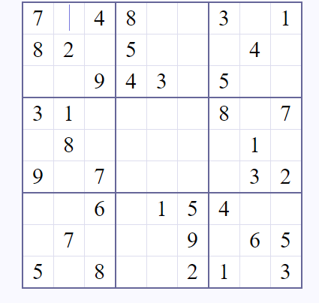

Solution

